5G NETWORK SLICING AND ITS APPLICATIONS IN INDUSTRY 4.0

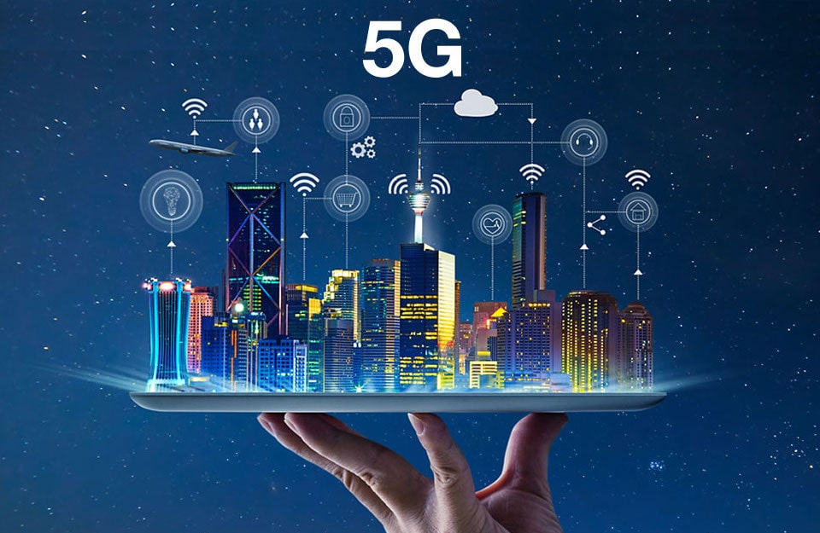

Highlights:

* What is network slicing?
* Architecture Overview
* How does network slicing benefit your business?
* How 5G network slicing enables smart factory?
* Applications of Network Slicing in Industry 4.0

What is network slicing?

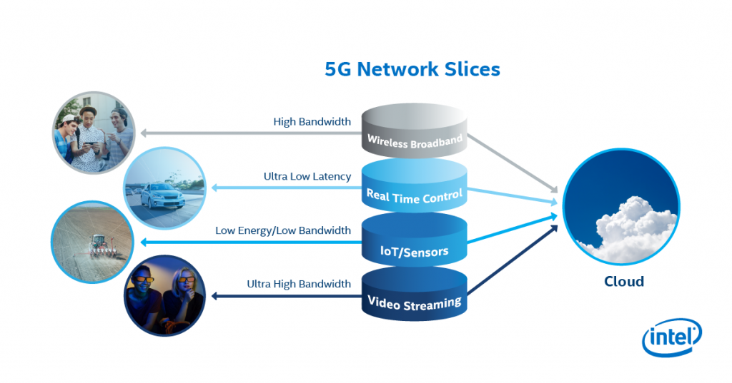

We are all well aware of the 5G technology , the quantum leap it brings in terms of speed , low latency and ultra-reliability . Network slicing is yet another exemplary feature which helps operators to create multiple virtual networks or “slices” that can be used in various areas for distinct application.

5G network slicing is the concept of virtualization of a network to divide a single network into multiple virtual networks that are tailored in such a way that they provide different amount of resources to different types of traffics as per the application requirement.

In network slicing , the primary focus is on logical(software-based) partitions and the physical components come second. In the earlier generations like 3G and 4G , if a customer required a guaranteed allocation for an application, the only way back then was the creation of a new physical network but this is no more the case now , and all because of 5G Network slicing. The realization of this service-oriented view of the network revolves around the concept of software-defined networking (SDN) and Network function Virtualization (NFV)) that allow the implementation of flexible and scalable network slices on top of a common network infrastructure.

How does slicing provide for a more flexible network?

* Flexibility: One of the most attractive benefit that network slicing offers is imparting agility and flexibility to the business operations. The problem of setting up a new network like in older generations is resolved by the slicing and configuring of segments . This provides the operator with an increased amount of flexibility to host a wide range of service requirements
* Security: Yet another advantage that network slicing has to offer is enhanced security measures , especially to slices that handle more crucial applications. The presence of slices ensures that in case there is a cyber attack , it is contained to only the breached slice and no harm is done to other parts of the network.
* Supports new technologies: Network slicing enables operators to support technical use cases such as autonomous cars with the help of 5G’s fast speed and low latency rates.

How does network slicing benefit your business?

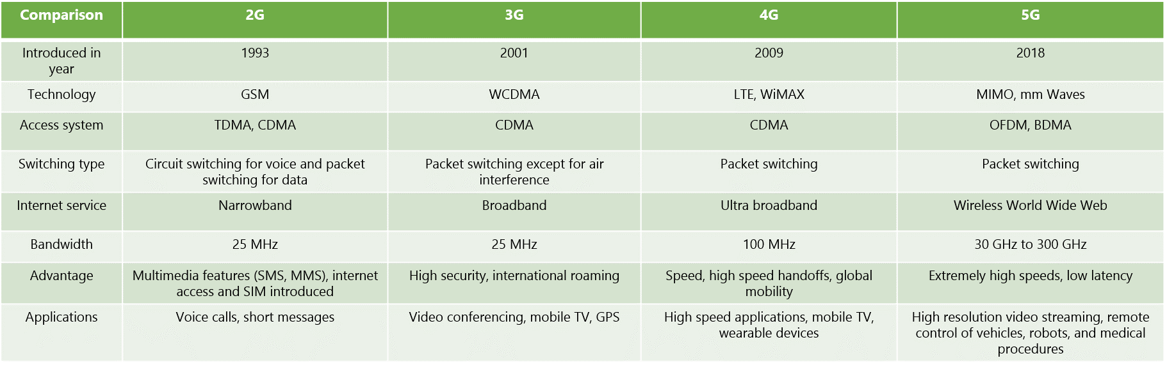

* Supports the adoption of new technologies: IoT is one of the technologies whose capacities are still not explored fully by many companies. 5G network slicing will enable businesses to utilize the full potential of IoT capabilities. Without the super speed and low latency of 5G networks , it becomes highly infeasible.
* Cost reduction : Network slicing helps in minimizing operating costs through wireless machines.
* Enhanced Performance : Distributing different parts of a network over a group of people increases its efficiency , speed and communication and lowers the cost , latency rate and time consumed.
* Protects Sensitive Data : Data present in different slices safeguards its privacy.

ARCHITECTURE OVERVIEW

The network slicing architecture can be broadly divided into two blocks , one dedicated to actual slice implementation and other to its configuration and management. The fist block consists of three layers whereas the second is designed to act as a central entity that handles and monitors that the other three layers are working in efficient coordination.

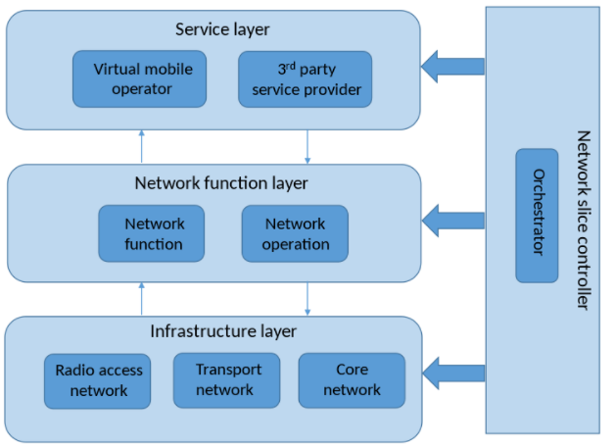

* **Software defined network(SDN)** : is a type of network architecture that enables the network to be programmed and controlled using software applications . It makes operations more flexible , consistent and aids operators to flexibly schedule and control network traffic, and realize network automation and intelligence.
* **Network function virtualization(NFV)** : is a network architecture concept that makes use of the technologies if IT virtualization to create the dynamics of the network element and provide virtual resources to decouple the hardware and software of the traditional telecommunication equipment.
* **SERVICE LAYER**

The service layer links directly with the network business entities for example third party service providers and provides an integrated vision of the service demands.

* **NETWORK FUNCTION LAYER:**

Creates network slice in accordance with the service instance requests received from the service layer. It comprises a set of *network functions* that embody well-defined behaviours and interfaces.

* **INFRASTRUCTURE LAYER**

This layer is responsible for providing the required physical network resources to host the network functions that make up each slice.

* **NETWORK SLICE CONTROLLER:**

Also defined as a network orchestrator , it overlooks the various functionalities carried out by each layer and coherently manages each slice request. It enables a smooth and flexible slice creation that can be reconfigured and it also provides for an effective co-ordination amongst the other three layer.

5G ENABLES SMART FACTORY

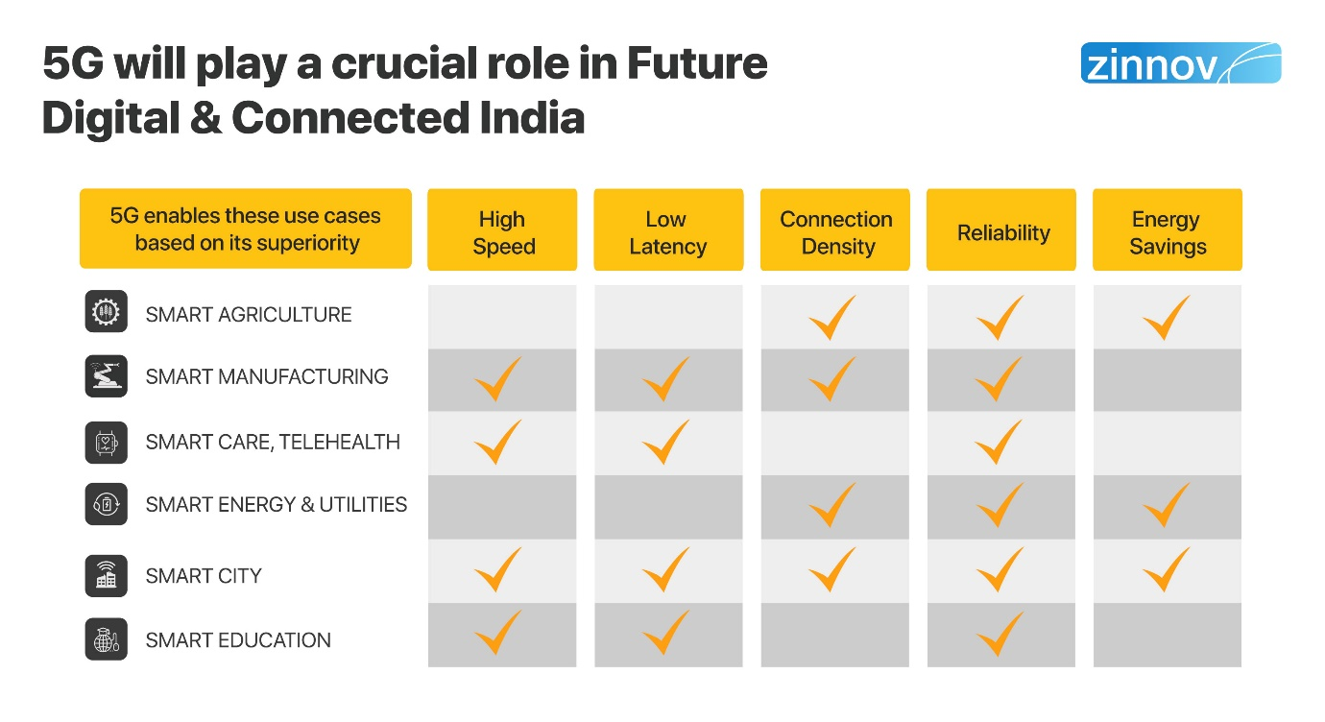

5G plays a crucial role in enabling smart factory and the factory of the future . 5G with its ability to create network slices can transform every industry and sector it touches impressively.

5G creates a dynamic, independent and powerful virtualized networks , each of which can be designed , deployed and controlled individually. NVF coupled with SDN helps slice the network into flexible layers which enables companies to optimize latency , transmission rates , security , time-to-market and expenses. The best part about this technology is that it helps businesses to customize the network according to what they want to provide their customers with.

5G promises to be a key enabler for smart factories . It aims to provide the unified communications platform needed to disrupt with new business models and to overcome the drawbacks of the current technologies. 5G network slicing has the potential to speeden up the ongoing transformation and open doors to new and much better levels of efficiency gains in the industry.

APPLICATIONS OF NETWORK SLICING IN INDUSTRY 4.0

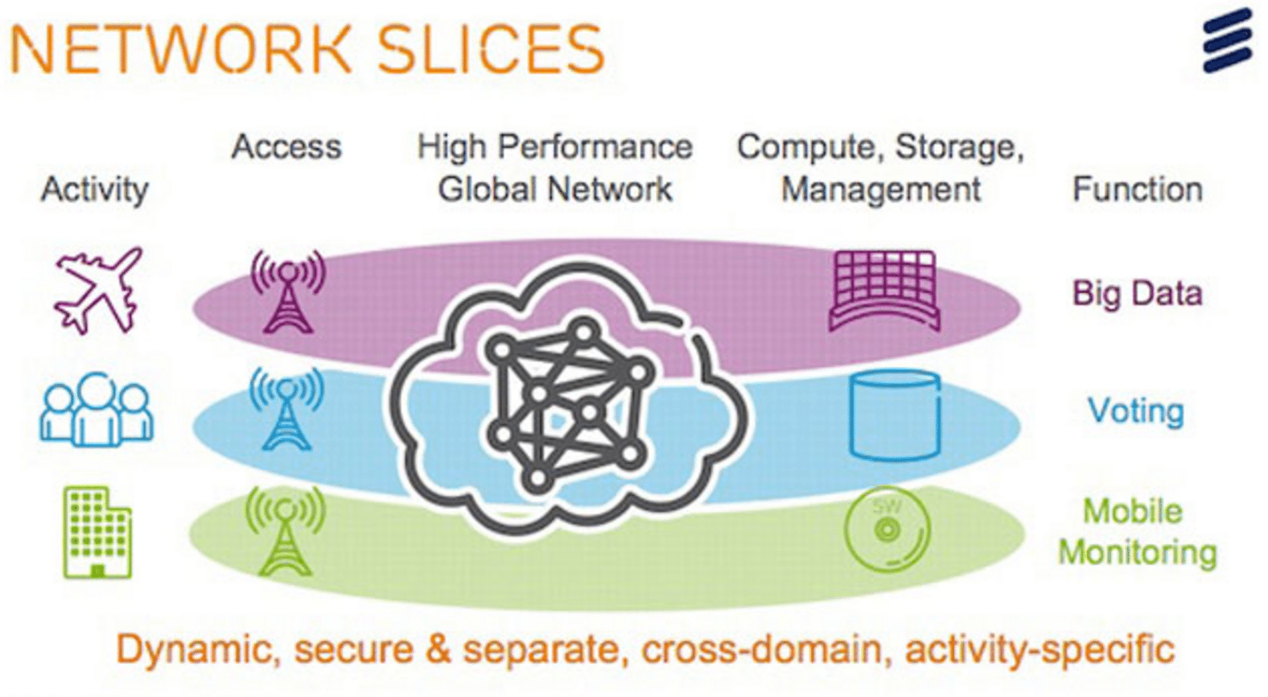

**5G network slicing can drive Industry 4.0.**

Industry 4.0 introduces blend of modern world technologies such as cloud computing, Internet of Things , cyber physical systems, etc. Furthermore the number of interconnected physical devices have increased drastically which introduces numerous challenges to industrial networks that have traditionally been unchanged and isolated. Many of these applications , machines and devices would need reliable connectivity and at the same time having requirements to the network , ranging from high reliability and low latency to high data rates. Current technologies are not well suited to match these requirements . The need here is of a network that is managed at an abstraction level. This is where network slicing comes into picture .

It handles all the aforementioned challenges by simplifying the manageability of heterogenous networks with various application requirements.

CONCLUSION

Network slicing has become one of the most effective network service capabilities in 5G networks. SDN and NFV have become the main technical support network section, through business scene demand for network customized cutting and realizing flexibility of network and optimizes business processes and data routing, with the help of cyber source to achieve the same. Simultaneously , it also meets the dynamic needs of users, so that the network has the ability to dynamically allocate resources, and more flexibly adapt to the real-time business needs of users.